Task 1: Create a table comparing Authentication, Authorization, and Accounting (AAA) by listing at least two real-world examples of each function from popular apps like Instagram, Zomato, or Paytm.
AAA Function | Basic Objective | Paytm | Instagram
Authentication (AuthN) | Verifies Identity: Confirms that a user is exactly who they claim to be before granting entry to the system. | Biometric Lockout: Prompting a user for a fingerprint or Face ID match alongside a silent hardware SIM-card verification token before unlocking access to a digital wallet. | Multi-Factor Login: Requesting a traditional username and password combination, followed immediately by a mandatory 6-digit SMS or Authenticator app one-time verification code.
Authorization (AuthZ) | Enforces Permissions: Restricts what specific actions, data metrics, or application features an identified user is legally allowed to execute. | Transaction Spending Limits: Allowing a full-KYC verified account to transfer up to ₹1,00,000 per day via UPI, while capping an unverified profile at a strict ₹10,000 wallet limit. | Account Type Boundaries: Granting an influencer with a "Professional Account" exclusive access to ad run metrics and monetization dashboards, which are completely hidden from standard consumer accounts.
Accounting (Acct) | Audits Behavior: Tracks and logs user sessions, data transfers, timestamps, and active locations for billing, diagnostics, or security analysis. | The Financial Ledger: Automatically recording the exact millisecond timestamp, transaction amount, unique merchant ID, and device GPS location for every payment made at a local store. | Security Session Audits: Keeping an active security history log that tracks the exact IP addresses, geographic cities, and device models that have logged into your profile to flag suspicious behavior.

Task 2: Draw a simple network diagram showing how AAA is used to secure access to a WiFi network in a college campus, labeling where authentication, authorization, and accounting take place. Include devices like user laptops, access points, AAA server, and the internet gateway.
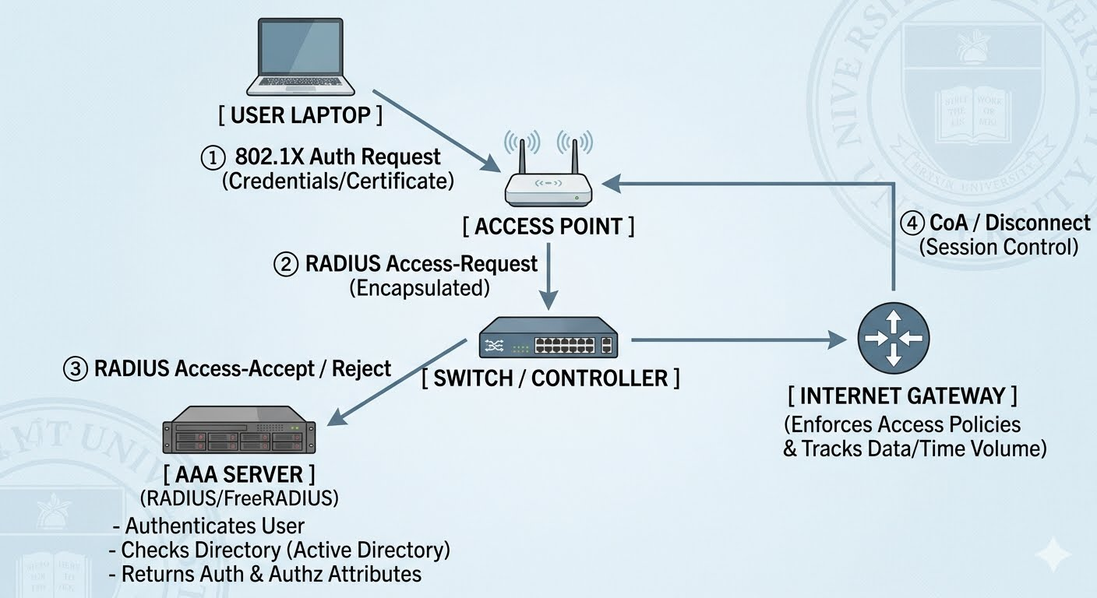

Phase-by-Phase AAA Functionality
To provide a thorough assignment response, the AAA framework is mapped directly to the hardware components in the diagram above:
1. Authentication
Where it occurs: This is a shared process between the User Laptop (Supplicant), the Access Point/Wireless LAN Controller (Authenticator), and the AAA Server (Authentication Server).
How it works:
The student or staff member attempts to connect to the campus Wi-Fi (usually via WPA3-Enterprise or 802.1X).
The laptop sends encryption credentials or digital certificates to the Access Point (AP).
The AP encapsulates this data and forwards a RADIUS Access-Request to the central AAA Server.
The AAA server checks the credentials against the campus identity database (e.g., Microsoft Active Directory or an LDAP server). If they match, identity is verified
2. Authorization
How it works
Once identity is verified, the AAA Server determines the user's role (e.g., Student, Faculty, or Guest).
The AAA server sends a RADIUS Access-Accept message back to the network infrastructure devices.
This packet contains specific authorization attributes, such as a VLAN ID, Quality of Service (QoS) limits, or Access Control Lists (ACLs).
For example, a student is authorized to access the Internet Gateway but restricted from reaching the internal staff servers.
3. Accounting
How it works
As soon as the laptop successfully connects, the network switch or wireless controller sends a RADIUS Accounting-Start packet to the AAA server to log the login timestamp.
During the session, interim updates track data volume (bytes sent/received) and connection duration.
When the user disconnects or roams off-campus, an Accounting-Stop packet is generated.
This provides the college IT department with an audit trail for security compliance, network troubleshooting, and bandwidth management
Task 2: Draw a simple network diagram showing how AAA is used to secure access to a WiFi network in a college campus, labeling where authentication, authorization, and accounting take place. Include devices like user laptops, access points, AAA server, and the internet gateway.
1. Centralized AAA Deployment Model
In a centralized model, all authentication, authorization, and accounting requests originating from any warehouse are sent back over a Wide Area Network (WAN) to a single primary cluster of AAA servers located at a corporate headquarters or a core data center.
How it works in a Flipkart
Access Request: A warehouse worker in Bengaluru scans a barcode using a handheld Wi-Fi scanner. The warehouse Access Point receives the request and packages it.
WAN Transit: The local network infrastructure routes the RADIUS/TACACS+ packet over the company's dedicated WAN link to the central data center in India.
Central Processing: The central AAA server verifies the scanner's credentials against the company-wide user database, confirms the worker's security clearance, and logs the login timestamp.
Enforcement: The central server sends an authorization approval back over the WAN, prompting the local warehouse switch to open network access.
Core Characteristics:
Single Point of Control: Configuration updates, access policies, and audit logs are managed from one dashboard.
High Latency: Network packets must travel across regional distances, which can cause subtle delays during login spikes (e.g., shifts changing during major sales like the Big Billion Days).
WAN Dependency: If the warehouse's internet or MPLS connection drops, local devices cannot authenticate, halting local warehouse operations even if the local Wi-Fi hardware is perfectly functional
2. Distributed AAA Deployment Model
In a distributed model, each major warehouse facility hosts its own local AAA server instance. While policies may be synchronized periodically from a central master server, all real-time access requests are evaluated locally on-site
How it works in a Flipkart Warehouse Scenario:
Access Request: A warehouse worker in Bengaluru connects a logistics automated guided vehicle (AGV) or scanner to the Wi-Fi.
Local Processing: The local Access Point routes the access request straight to an on-site, dedicated local AAA appliance or edge server.
Local Decision: The local server processes the request immediately against a locally cached, synchronized database, granting access privileges without reaching out to the main data center.
Background Sync: At off-peak times or in near real-time, the local server sends accounting logs and audit data back to the central data center to maintain unified records.
Core Characteristics:
Survives Network Drops: If a regional fiber line is cut and a warehouse completely loses external internet connectivity, internal operations continue uninterrupted. Scanners, automated conveyor belts, and local computers can still authenticate and interact locally.
Ultra-Low Latency: Authentication occurs in milliseconds because packets never leave the local area network (LAN).Management Complexity: Maintaining, upgrading, and troubleshooting dozens of individual AAA server deployments across various regions increases overall IT overhead
Task 3: Explain the difference between centralized and distributed AAA deployment models by describing how each would work in a scenario where multiple Flipkart warehouses need secure network access.
1. Centralized AAA Deployment Model
In a centralized model, all authentication, authorization, and accounting requests originating from any warehouse are sent back over a Wide Area Network (WAN) to a single primary cluster of AAA servers located at a corporate headquarters or a core data center.
How it works in a Flipkart Warehouse Scenario:
Access Request: A warehouse worker in Bengaluru scans a barcode using a handheld Wi-Fi scanner. The warehouse Access Point receives the request and packages it.
WAN Transit: The local network infrastructure routes the RADIUS/TACACS+ packet over the company's dedicated WAN link to the central data center.
Central Processing: The central AAA server verifies the scanner's credentials against the company-wide user database, confirms the worker's security clearance, and logs the login timestamp.
Enforcement: The central server sends an authorization approval back over the WAN, prompting the local warehouse switch to open network access.
Core Characteristics:
Single Point of Control: Configuration updates, access policies, and audit logs are managed from one dashboard.
High Latency: Network packets must travel across regional distances, which can cause subtle delays during login spikes (e.g., shifts changing during major sales like the Big Billion Days).
WAN Dependency: If the warehouse's internet or MPLS connection drops, local devices cannot authenticate, halting local warehouse operations even if the local Wi-Fi hardware is perfectly functional.

2. Distributed AAA Deployment Model
In a distributed model, each major warehouse facility hosts its own local AAA server instance. While policies may be synchronized periodically from a central master server, all real-time access requests are evaluated locally on-site.
Access Request: A warehouse worker in Bengaluru connects a logistics automated guided vehicle (AGV) or scanner to the Wi-Fi.
Local Processing: The local Access Point routes the access request straight to an on-site, dedicated local AAA appliance or edge server.
Local Decision: The local server processes the request immediately against a locally cached, synchronized database, granting access privileges without reaching out to the main data center.
Background Sync: At off-peak times or in near real-time, the local server sends accounting logs and audit data back to the central data center to maintain unified records.
Core Characteristics:
Survives Network Drops: If a regional fiber line is cut and a warehouse completely loses external internet connectivity, internal operations continue uninterrupted. Scanners, automated conveyor belts, and local computers can still authenticate and interact locally.
Ultra-Low Latency: Authentication occurs in milliseconds because packets never leave the local area network (LAN).
Management Complexity: Maintaining, upgrading, and troubleshooting dozens of individual AAA server deployments across various regions increases overall IT overhead.
Task 4: Pick any one AAA deployment model and list three advantages and two disadvantages of using it for a large-scale app like BookMyShow.
Choosing the Distributed AAA Deployment Model, where localized AAA edge nodes or containerized server instances are deployed regionally close to the user base (e.g., across regional cloud zones or edge data centers), offers distinct operational trade-offs.
Advantages of a Distributed AAA Model for BookMyShow
Ultra-Low Latency Handling: User authentication requests are processed at the nearest regional edge node rather than traveling back to a single central data center. This eliminates network transit delays, ensuring milliseconds-fast login speeds when millions of users simultaneously try to grab high-demand concert tickets.
High Scalability during Peak Traffic: Massive traffic spikes during major event openings are distributed across regional authentication nodes. This prevents a single central authentication database from becoming a bottleneck, avoiding system-wide login crashes.
Localized Fault Isolation: If a regional cloud zone or network link experiences an outage, the failure is contained to that specific region. Users in other regions can continue to log in, browse, and purchase tickets without a global platform blackout.
Disadvantages of a Distributed AAA Model for BookMyShow
Data Synchronization Hurdles: Maintaining real-time consistency across distributed authentication databases is highly complex. For example, if a user updates their account password or multi-factor authentication (MFA) settings in one region, there can be a slight delay before that change propagates globally, leading to temporary authentication errors if they travel or log in from a different endpoint.
Increased Operational and Maintenance Overhead: Deploying, monitoring, patching, and securing multiple AAA instances across various geographical zones significantly increases infrastructure costs and requires complex automated configuration management tools to keep all nodes identical and secure.
Task 5: AI-Generated AAA Security Policy: Food Delivery & Logistics Platform
1. Authentication
Customer App Auth: Handled via JSON Web Tokens (JWT) following OAuth 2.0 protocols via Google, Apple, or Phone Number OTP.
Delivery Partner App Auth: Handled via Phone Number OTP + real-time biometric facial scanning at daily shift log-in.
Restaurant Partner Dashboard Auth: Handled via Email/Password credentials backed by Mandatory Multi-Factor Authentication (MFA).
Internal Admin/Support Portal Auth: Enforced via Corporate Single Sign-On (SSO) integrated with Active Directory, requiring hardware-based MFA keys.
2. Role-Based Authorization Matrix
Action Token | Description | Authorized Roles
ACTION_BROWSE | View restaurant menus, ratings, prices, and locations. | Customer, Guest (Anonymous)
ACTION_ORDER | Place orders, checkout carts, process digital payments. | Customer
ACTION_DISPATCH | Accept delivery runs, view customer addresses, complete orders. | Delivery Partner
ACTION_MENU_MOD | Modify dish availability, update restaurant pricing, set active hours. | Restaurant Owner, Support Admin
ACTION_REFUND | Revoke transactions, trigger monetary balance refunds to consumers. | Support Manager, Finance Admin
ACTION_DB_WRITE | Directly alter database schemas or execute backend configuration scripts. | DevOps Lead, Principal Architect

3. Accounting & Auditing Specification
Transactional Auditing: Every ACTION_ORDER and ACTION_REFUND triggers a structured audit payload capturing Timestamp, User UUID, IP Address, Payment Gateway Reference ID, and Net Value.
Location Tracking Continuity: While a delivery run is marked active, GPS coordinates from the Delivery Partner device must be captured and streamed to the accounting database at 15-second intervals.
Privileged Session Logs: Any ACTION_MENU_MOD or ACTION_REFUND requires immutable logging capturing the system administrator's employee ID, session duration, altered values (pre-vs-post snapshot), and approval reference codes.
Critical Security Flaw & Required Modification
The Flaw: Under ACTION_DISPATCH, the authorization matrix allows Delivery Partners to view "customer addresses" directly during dispatch execution. Additionally, the Accounting section notes that "GPS coordinates from the Delivery Partner device must be captured" but lacks structured safeguards on how that location data is isolated or how customer location histories are managed. Storing plain-text addresses or unencrypted route histories creates a massive target for data leaks and worker-to-customer stalking risks.
The Fix (Data Minimization & Dynamic Masking):To enhance platform security and user privacy, implement Dynamic Address Masking and Geofencing.
Address Masking: Modify ACTION_DISPATCH so the delivery partner never sees the customer’s precise written address or phone number in cleartext on their application UI. Instead, the application passes coordinates natively to an in-app map layer.
Geofenced Access: The precise coordinate tracking data or drop-off doorbell specifics must remain encrypted and should only decrypt on the delivery partner's terminal when they enter a 50-meter geofenced radius around the destination point.

Ephemeral Accounting: As soon as an accounting log confirms the delivery run is marked "Complete," the customer's location footprint must be instantly wiped from the active session cache and archived into a separate, highly restricted cold-storage audit table with minimal access privileges.

